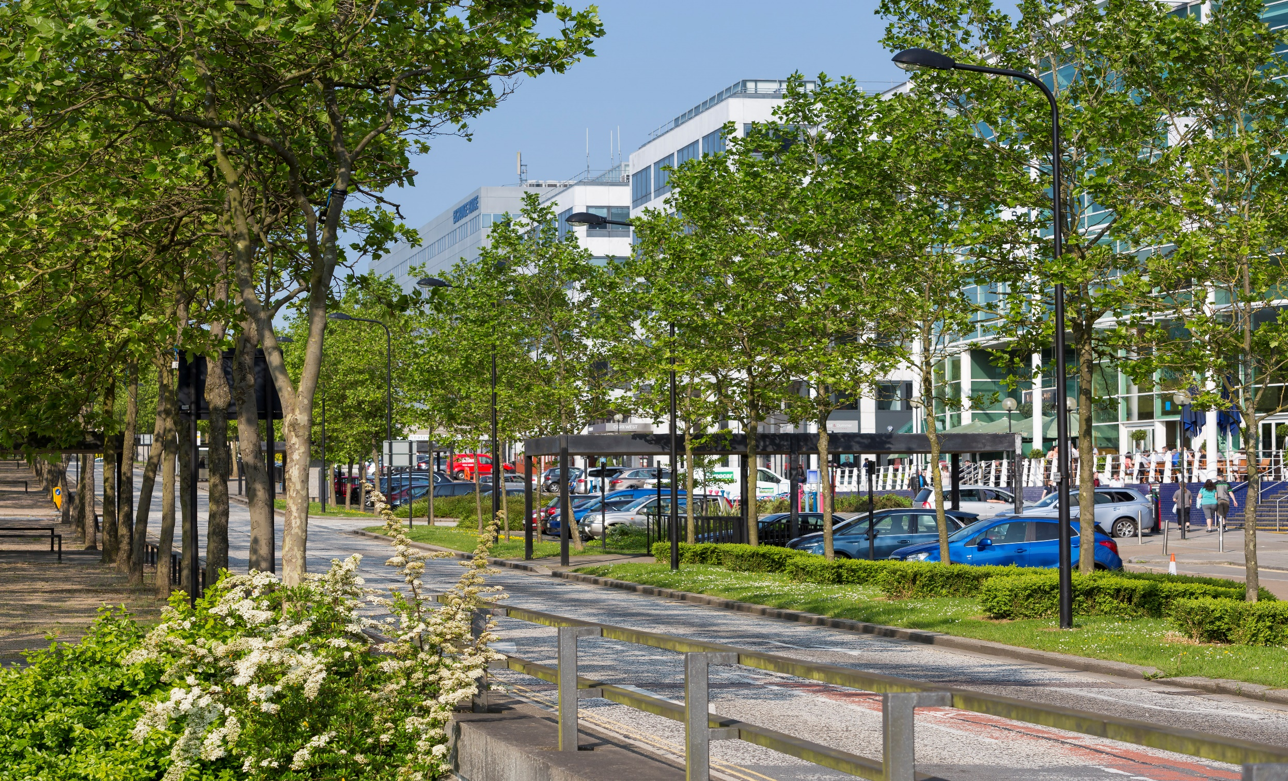




Green Business Fund

Application Form

v.1.0 March 2026

Green Business Fund Application Form

Introduction
Thank you for your interest in applying for a grant from the Green Business Fund. The primary goal of the Fund is to support businesses across Milton Keynes to become more sustainable, resource efficient and reduce emissions.

Applying to the Green Business Fund

You are invited to complete this application form seeking funding from the Milton Keynes City Council.

This application form should be completed and submitted electronically to
carbon@milton-keynes.gov.uk.

Successful applicants will need to sign a grant funding agreement with Milton Keynes City Council and will also be required to participate in an evaluation of their project to understand whether the proposed outputs and outcomes have been met.

Should you require any clarification regarding completion of this form, please contact aleksandar.bogdanov@milton-keynes.gov.uk or carbon@milton-keynes.gov.uk

Project Summary (not assessed)
Name of Organisation
Name of Project
Project Summary (100 words limit)
Amount Applied for
Where will the project be delivered?
Deliverables (Outputs)

Section 1:
Applicant Information

  - Name of Organisation

  - Name of lead applicant

  - Position within Organisation
  - Contact email address

  - Contact telephone number

  - Registered Address

  - Delivery Address (if different to above)
  - Organisation type

  - Charity or company registration number

  - VAT registration number

  - Organisations that are not a public body, will be asked to also submit the following:
- Proof of existence - Certificate of Incorporation, Charities Registration, VAT Registration Certificate or alternate form of incorporation documentation

Section 2:
Project Summary

2.1) Project Name

2.2) Please provide a summary of your project
- What would you like to deliver?
- What activities will take place and where?
- How will the activities be delivered?

Please limit your response to 250 words

2.3) How will your project improve sustainability for businesses across the city?

- How will the activities reduce greenhouse gas emissions, improve resource efficiency, or enhance sustainability skills?

Please limit your response to 250 words

2.4) What is the need for the project?
- How does your project add value beyond existing support available locally or nationally?

2.5) Who will deliver the activities and how will they be delivered?
- Please provide details of all other partners who will be involved in the project

2.7) What outputs will the project deliver?
- Please also provide a delivery target

2.8) How have these outputs been estimated?

2.11 What local support can be demonstrated for the delivery of the project, and does it link with existing programmes being delivered?

Section 3:
Project Costs

3.1) How much funding are you applying for? | £
3.2) What is the cost of implementing your project?
- Please provide a clear breakdown of your costs

3.3) How does your proposal demonstrate value for money?
3.4) Optional - If you have matched funding for this project, please provide details here, including the source of the funding and if it has been secured.

3.5) Explain why the project could not
proceed without a grant from the Green Business Fund?

Section 4:
Project Management

4.1) Please provide details of the project management process you will have in place to manage the grant.

This may include governance arrangements, management information, and where applicable, the arrangements for managing your delivery partners.

Please limit your response to 250 words

4.2) Please set out the roles and responsibilities of staff who will be involved in the delivery of your project (including staff managed by your delivery partners, if applicable).

4.3) Please provide details of any previous experience your organisation has managing and delivering similar projects.

4.5) Please describe the key risks you envisage could affect the delivery of your project.

4.6) Within the timeframe for your project, we are keen to understand how it will be set-up, delivered and monitored. Please include key activities and dates. | Proposed Activity | Target Date
4.7) Describe how the project will be evaluated in terms of how it will be delivered and potential impact.

4.8) Please confirm you have read, and will comply with, the branding and publicity guidance:  The applicant will ensure that any communications or publicity by the applicant in relation to the works which the Council Funding has contributed towards will include acknowledgment of the Council Funding. The applicant will ensure that any communications or publicity will not go live before the Council has made announcement of the successful funding. |  | Yes  No
4.9) If your project/organisation is working with young people we need your organisation to have the Milton Keynes Youth Provision Safe Practice Mark, do you have the Mark?  - The Safe Practice Mark is awarded to organisations providing youth services. It provides assurance to those using the services that correct safeguards are in place.  - If you do not currently, have it, we can still consider your project as long as you have the mark before any contract / agreement is signed if successful with your application.  - For more information go to: Milton Keynes Youth Provision Safe Practice Mark |  | Yes  No  Not applicable

Section 5:
Declarations

Data Protection and General Data Protection Regulation (GDPR)

Milton Keynes City Council will be a Data Controller for all Green Business Fund related Personal Data collected with the relevant forms as part of this process, and the control and processing of Personal Data.

By proceeding to complete and submit this form, you consent that the Council and its contractors, where relevant may process the Personal Data that it collects from you.

Data Controller, Personal Data, Personal Data and Processor all have the meaning given to them in the Data Protection Legislation (as amended from time to time).

For further information about how Milton Keynes City Council use your data please use the following link.

Subsidy Control

Subsidy shall have the meaning given to it in the Subsidy Control Act (SCA) 2022.

When the Council is considering the award of a financial assistance or a grant, the subsidy control regime governed by the SCA 2022 must be considered and the full principles and requirements adhered if applicable.

Some subsidies could be deemed exempt from many of the substantive requirements of the SCA 2022 if they are granted as Minimal Financial Assistance (MFA) by the Public Authority. MFA has a financial threshold of £315,000 over an applicable period. The applicable period is the period comprising the current financial year to date and the two financial years immediately preceding the current financial year. If the recipient of the subsidy has received more than £315,000 (this includes the subsidy proposed) MFA will not be applicable and the substantive requirements of the SCA 2022 shall apply (i.e. full consideration of the Principles under the Act as required).

Before awarding an MFA subsidy, Milton Keynes City Council as a Public Authority must provide the intended recipient enterprise with an ‘MFA notification’. An MFA notification means a written statement: explaining that the public authority is proposing to give to the enterprise a subsidy by way of MFA, specifying the gross value amount of the assistance, and requesting written confirmation from the enterprise that the MFA threshold of £315,000 will not be exceeded by the enterprise receiving the proposed assistance.

The Council can only award the subsidy as an MFA when it has received this confirmation.

For more information on the Subsidy Control Act 2022, please use the following link

Project Statement

I declare that I have the authority to represent the lead applicant in submitting this application.

I understand that acceptance of this application form by Milton Keynes City Council (MKCC) does not in any way signify that the project is eligible for funding under the Green Business Fund or that any such funding has been approved towards it.

On behalf of the lead applicant and having carried out full and proper inquiry, I confirm to MKCC that:
- the lead applicant has the legal authority to carry out the project; and
- the information provided in this application is accurate.

I also confirm to MKCC that:

- I have informed all persons, whose personal information I have provided in this application, of the personal information I have provided to you and of the purposes for which this information will be used, and that I have the consent of the individuals concerned to pass this information to you for these purposes.
- I consent to the Personal Data submitted with this form being shared as set out in this form and in accordance with MKCC’s Privacy Policies.
- I shall inform MKCC if, prior to any Green Business Fund funding being legally committed to the lead applicant, I become aware of any further information which might reasonably be considered as material to the Lead Authority in deciding whether to fund the proposal.
- Any match funding, if applicable, that has been set out in this application will be in place prior to any award of the Green Business Fund.
- I am aware that if the information given in this application turns out to be false or misleading, MKCC may demand the repayment of funding and/or terminate a funding agreement pertaining to this proposal.

I confirm that should the grant fall within MFA, I shall provide the written confirmation as outlined in the MFA Notification. I understand that the Council can only award the subsidy as an MFA when it has received this confirmation.

I confirm that I am aware that checks can be made to the relevant authorities to verify this declaration and any person who knowingly or recklessly makes any false statement for the purpose of obtaining grant funding or for the purpose of assisting any person to obtain grant funding may be prosecuted. A false or misleading statement will also mean that approval may be revoked, and any grant may be withheld or recovered with interest.

I confirm that I understand that if the lead applicant commences project activity, or enters into any legally binding contracts or agreements, including the ordering or purchasing of any equipment or services, before the formal approval of the project, any expenditure is incurred at the organisation’s own risk and may render the project ineligible for support.

Signed for and on behalf of the organisation |  | Date
Name

Position

Appendix 1 – Subsidy control checks

Subsidy Control
The Council is required to consider application of subsidy in transactions.
Whether or not a transaction constitutes a subsidy is partly determined by the activities of the recipient organisation. Please could you answer the following questions to help us with assessing whether transactions with your organisation could constitute a subsidy within the meaning of the Subsidy Control Act 2022:
 | Questions | Response
1. | Is [organisation] a public or private body?
2. | In awarding contracts to third parties, is [organisation] required by law to comply with Procurement Act 2023
3. | Is [organisation] required by law to comply with subsidy control legislation (formerly state aid law)?
4. | Is [organisation] a charity? If yes, please provide charity registration number.
5. | If yes to question 4 above, what is the main purpose of the charity?
6. | Does [organisation] offer goods or services in the market?
7. | If yes to question 6 above, what goods or services does [organisation] offer in the market?
8. | If yes to question 6 above, what generally happens to any proceeds received from such goods or services?
9. | Is [organisation] registered at Companies House?
10. | If yes to question 9 above, please provide company registration details.
11. | If the applicant is a private body or a charity, starting from this financial year and also looking back at the previous two financial years, have you received financial assistance from any public bodies, including Milton Keynes City Council, totalling £315k in that period?
12 | If no to question 11 above, would receiving the amount of funding that you have applied for cause you to have received more than £315k over the financial period stated at question 11 above?

Appendix 2 – Activity explicitly excluded from this funding

- Paid for lobbying; which means using grant funds to fund lobbying (via an external firm or inhouse staff) to undertake activities intended to influence or attempt to influence Parliament, Government, or political activity; or attempting to influence legislative or regulatory action
- Using grant funds to directly enable one part of government to challenge another on topics unrelated to the agreed purpose of the grant
- Using grant funding to petition for additional funding
- Expenses such as for entertaining; specifically aimed at exerting undue influence to change government policy
- VAT reclaimable from HMRC; VAT that cannot be recovered from HMRC is an eligible cost
- Payments for activities of a party political or exclusively religious nature
- Interest payments or service charge payments for finance leases
- Gifts, or payments for gifts or donations
- Statutory fines, criminal fines, or penalties
- Payments for works or activities which the Lead Authority, project deliverer, end beneficiary, or any member of their partnership has a statutory duty to undertake, or that are fully funded by other sources
- Bad debts to related parties
- Payments for unfair dismissal or other compensation
- Depreciation or amortisation costs
- Contingencies and contingent liabilities
- Dividends
- Costs resulting from the deferral of payments to creditors
- Costs involved in winding up a company
- Legal expenses in respect of litigation
- Costs incurred by individuals in setting up and contributing towards private pension schemes
- Payments that breach or are contrary to the funding agreement or UK legislation

